Lab - 3: Generating & Observing Signals
Lab Tasks
1. Write a function to generate and plot impulse sequences. The first line of the file should provide the function definition as follows:
function [x,n] = impulsesequence(n0,n1,n2)
if ((n0 > n1) | (n0 < n2) | (n1 < n2)) % Checks input parameters are valid
error('ensure arguments satisfy n1 <= n0 <= n2')
end
n = [n1:n2]; % defines the range over which the sequence is taken
x = [(n-n0) == 0]; % creates the impulse sequence using logical operator
stem(n,x) % plots a stem graph of output
Note: The function name and the name under which the file is saved must be the same, i.e. impulsesequence.m. Also ensure when running the file that you are working in the same directory that the function is saved in.
Using the impulsesequence function, generate the following impulse sequences and make sketches of the following signals
Code
function [x,n] = impulsesequence(n0,n1,n2)
% Check if the input parameters are valid
if ((n0 > n2) || (n0 < n1) || (n1 > n2))
error('Ensure arguments satisfy n1 <= n0 <= n2');
end
% Define the range over which the sequence is taken
n = [n1:n2];
% Create the impulse sequence using logical operator
x = (n == n0);
% Plot the stem graph of output
stem(n,x);
xlabel('n');
ylabel('Amplitude');
title(['Impulse Sequence ?(n-', num2str(n0), ')']);
grid on;
end
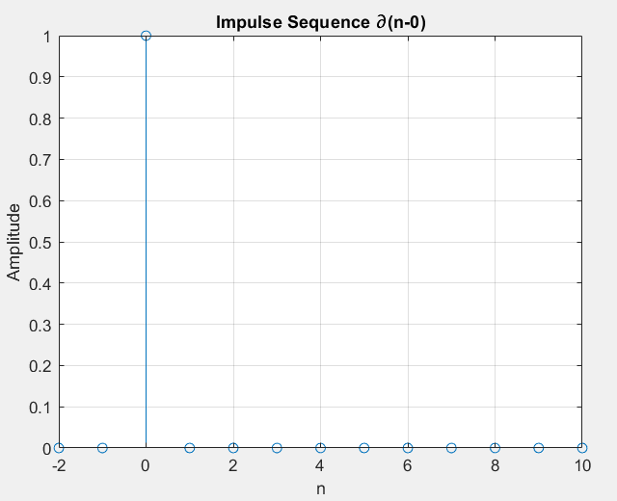
i. ∂(n) -2 ≤ n ≤ 10
clcimpulsesequence(0, -2, 10);

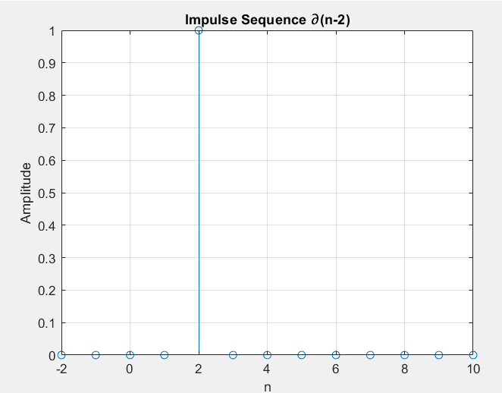
ii. ∂(n – 2) -2 ≤ n ≤ 10;
clc
impulsesequence(2, -2, 10);

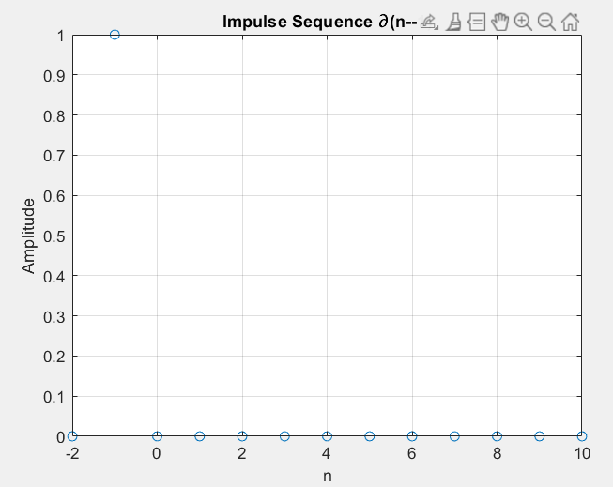
iii. ∂(n + 1) -2 ≤ n ≤ 10;
clc
impulsesequence(-1, -2, 10);

2. Write a function in MATLAB to generate and plot step sequences. The function definition and the body is given below. Enter the script in a file named stepsequence.m in your current folder.
function [x,n] = stepsequence(n0,n1,n2)
if ((n0 > n1) | (n0 < n2) | (n1 < n2)) % Check input parameters are valid
error('ensure arguments satisfy: n1 <= n0 <= n2') end
n = [n1:n2]; % defines the range over which the sequence is taken
x = [(n-n0)>= 0]; % creates step sequence using logical operator
stem(n,x) % plots a stem graph of output
Using the stepsequence function, generate the following impulse sequences and make sketches of the following step signals:

Function:
function [x, n] = stepsequence(n0, n1, n2)
% Check if input parameters are valid
if ~(n1 <= n0 && n0 <= n2)
error('Ensure arguments satisfy: n1 <= n0 <= n2');
end
% Define the range over which the sequence is taken
n = n1:n2;
% Create the step sequence using logical operations
x = (n - n0) >= 0;
end

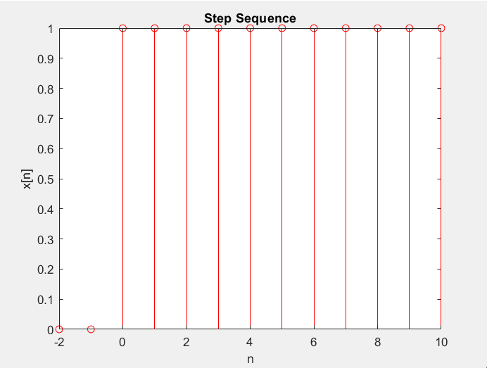
i. u(n) -2 ≤ n ≤ 10 ;
% Define parameters
n0 = 0; n1 = -2; n2 = 10;

% Call the function
[x, n] = stepsequence(n0, n1, n2);

% Plot the result
stem(n, x,'r');
title('Step Sequence');
xlabel('n');
ylabel('x[n]');

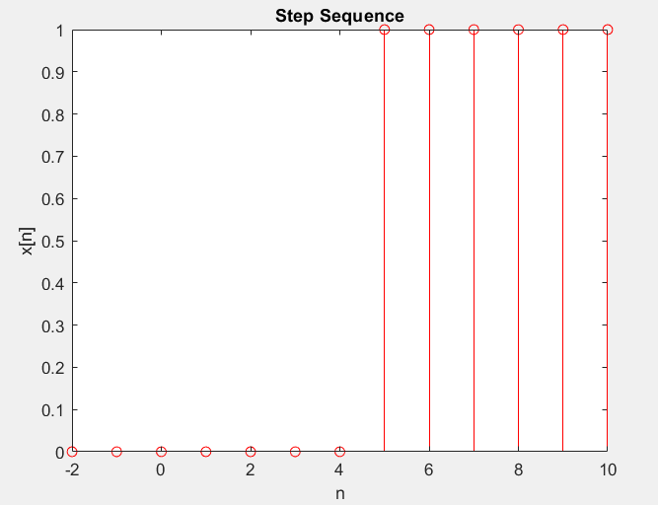
ii. u(n - 5) -2 ≤ n ≤ 10;
% Define parameters
n0 = 5; n1 = -2; n2 = 10;

% Call the function
[x, n] = stepsequence(n0, n1, n2);

% Plot the result
stem(n, x,'r');
title('Step Sequence');
xlabel('n');
ylabel('x[n]');

iii. u(n - 20) 0 ≤ n ≤ 100;
% Define parameters
n0 = 20; n1 = -2; n2 = 30;
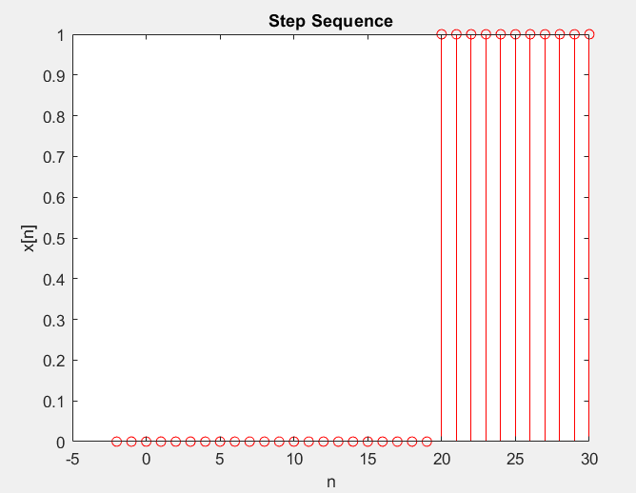
% Call the function
[x, n] = stepsequence(n0, n1, n2);

% Plot the result
stem(n, x,'r');
title('Step Sequence');
xlabel('n');
ylabel('x[n]');

3. Generate and plot the following exponential sequences in MATLAB.
i. (0.1)n -10 ≤ n ≤ 10; i.e. in MATLAB » n = [-10:10];
ii. (0.5)n -10 ≤ n ≤ 10;
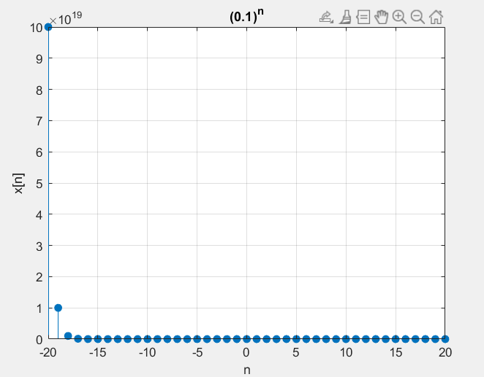
iii. (1.1)n -10 ≤ n ≤ 10;
iv. (10)n -10 ≤ n ≤ 10;
v. e(2 + 3j)n -10 ≤ n ≤ 10
vi. e(0.2 + 0.3j)n -10 ≤ n ≤ 10

CODE
n = -20:20;

% i. (0.1)^n
x1 = (0.1).^n;
figure;
stem(n, x1, 'filled');
title('(0.1)^n');
xlabel('n');
ylabel('x[n]');
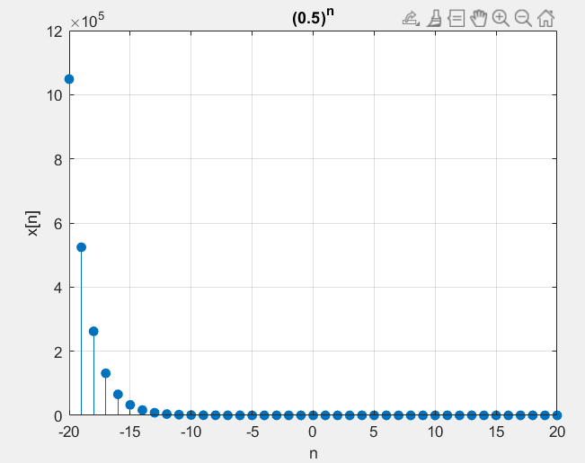
grid on;

% ii. (0.5)^n
x2 = (0.5).^n;
figure;
stem(n, x2, 'filled');
title('(0.5)^n');
xlabel('n');
ylabel('x[n]');
grid on;

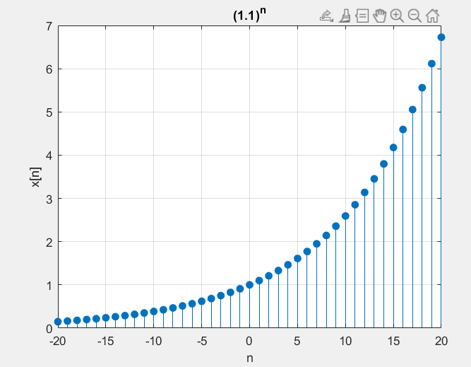
% iii. (1.1)^n
x3 = (1.1).^n;
figure;
stem(n, x3, 'filled');
title('(1.1)^n');
xlabel('n');
ylabel('x[n]');
grid on;

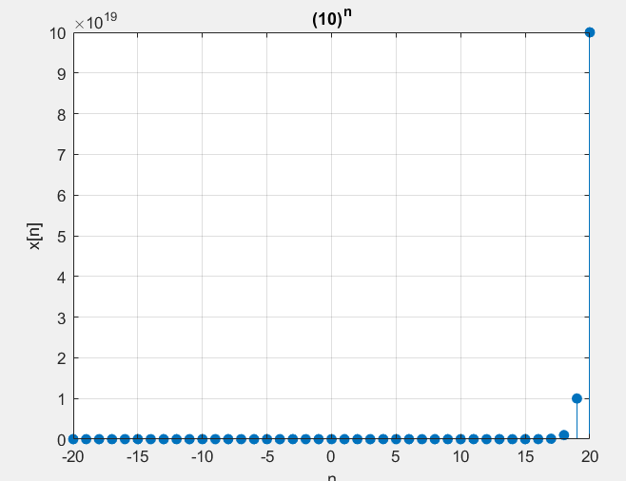
% iv. (10)^n
x4 = (10).^n;
figure;
stem(n, x4, 'filled');
title('(10)^n');
xlabel('n');
ylabel('x[n]');
grid on;

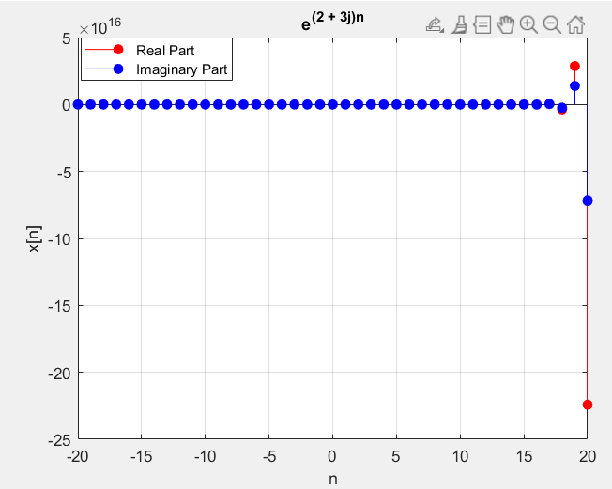
% v. e^(2 + 3j)^n
x5 = exp((2 + 3j) .* n);
figure;
stem(n, real(x5), 'r', 'filled');
hold on;
stem(n, imag(x5), 'b', 'filled');
title('e^{(2 + 3j)n}');
xlabel('n');
ylabel('x[n]');
legend('Real Part', 'Imaginary Part');
grid on;

% vi. e^(0.2 + 0.3j)^n
x6 = exp((0.2 + 0.3j) .* n);
figure;
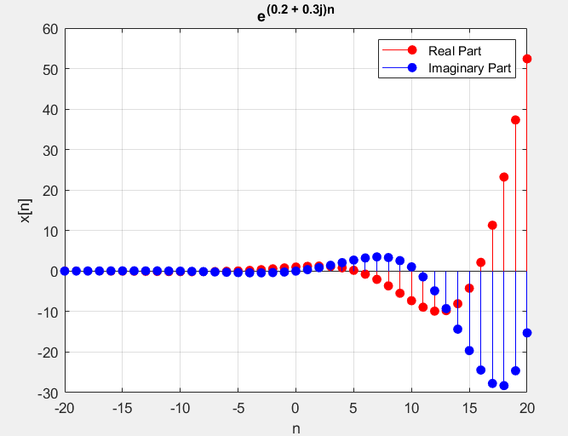
stem(n, real(x6), 'r', 'filled');
hold on;
stem(n, imag(x6), 'b', 'filled');
title('e^{(0.2 + 0.3j)n}');
xlabel('n');
ylabel('x[n]');
legend('Real Part', 'Imaginary Part');
grid on;

4. Now look at Noise signals. These are modelled by random processes. Using MATLAB, we write:
» noise = rand (1,101);
» time = [0: 0.01: 1.0];
» plot(time, noise);
This is an example of uniformly distributed random sequence. All values lie in the range of [0, 1]. To remove d.c. and scale the signal to lie in [-1, 1], do:
» noise = 2*(rand (1,101) - 0.5);
Note: Remember to plot and sketch these.
Read up about noise and random signals and why they are so important in signal processing and Communications theory.
CODE
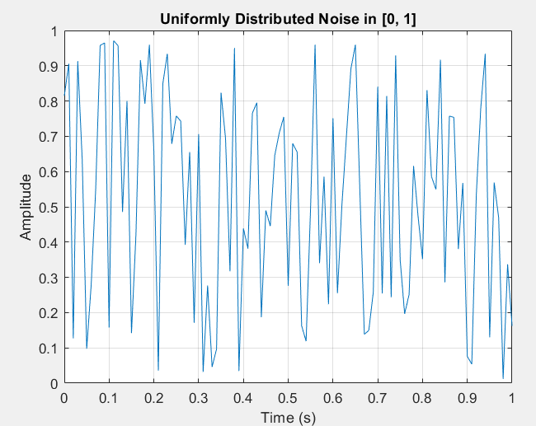
% Uniformly distributed noise in [0, 1]
noise1 = rand(1, 101); % Generate 101 random values in [0, 1]
time = 0:0.01:1.0; % Define time from 0 to 1 in steps of 0.01
figure;
plot(time, noise1);
title('Uniformly Distributed Noise in [0, 1]');
xlabel('Time (s)');
ylabel('Amplitude');
grid on;

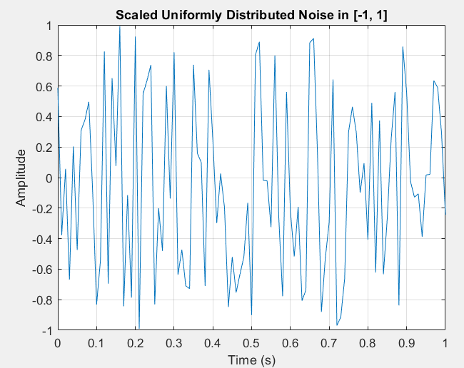
% Scale noise to lie in [-1, 1]
noise2 = 2 * (rand(1, 101) - 0.5); % Scale and shift
figure;
plot(time, noise2);
title('Scaled Uniformly Distributed Noise in [-1, 1]');
xlabel('Time (s)');
ylabel('Amplitude');
grid on;

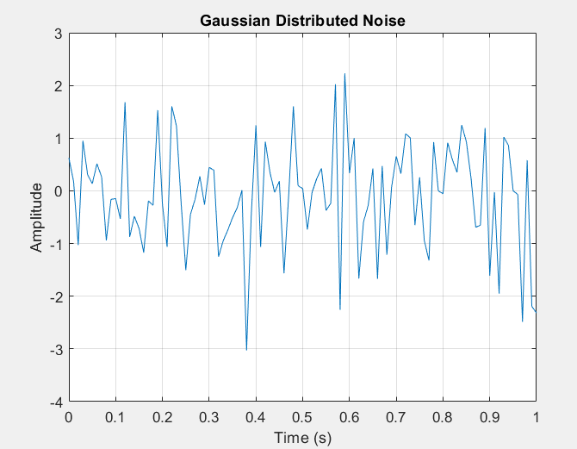
% Generate Gaussian noise
noise3 = randn(1, 101);
% Standard normal distribution (mean=0, std=1)
figure;
plot(time, noise3);
title('Gaussian Distributed Noise');
xlabel('Time (s)');
ylabel('Amplitude');
grid on;

% Histogram comparison
figure;
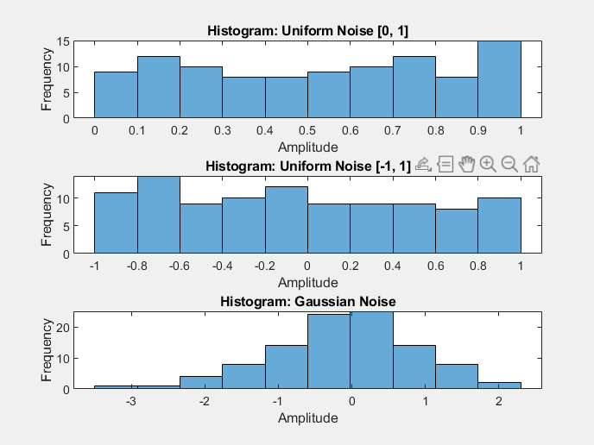
subplot(3, 1, 1);
histogram(noise1, 10);
title('Histogram: Uniform Noise [0, 1]');
xlabel('Amplitude');
ylabel('Frequency');

subplot(3, 1, 2);
histogram(noise2, 10);
title('Histogram: Uniform Noise [-1, 1]');
xlabel('Amplitude');
ylabel('Frequency');

subplot(3, 1, 3);
histogram(noise3, 10);
title('Histogram: Gaussian Noise');
xlabel('Amplitude');
ylabel('Frequency');
5. A sinusoid type signal can be generated as follows:
N = 128; % 64 data points
fs = 1000; % % 1kHz sampling frequency
T = 1/fs; % sample period
f = 400; % signal frequency
n = 0:N-1/N; % discrete time vector
x = cos(2*pi*f*n*T); % signal definition
plot(n*T,x);
xlabel('Time ----->')
ylabel('Amplitude ----->') ;
You can ‘listen’ to the signal through a pair of headphones using the command:
soundsc(x,1/T);
Note: Try adjusting the frequency and duration

CODE
% Parameters
N = 128; % Number of data points
fs = 2000; % Sampling frequency (1 kHz)
T = 1/fs; % Sampling period
f = 400; % Signal frequency (400 Hz)
n = 0:N-1; % Discrete time vector

% Generate sinusoidal signal
x = cos(2 * pi * f * n * T); % Signal definition
% Plot the sinusoidal signal
figure;
plot(n * T, x);
title('Sinusoidal Signal');
xlabel('Time (s) ----->');
ylabel('Amplitude ----->');
grid on;

% Play the sinusoidal signal
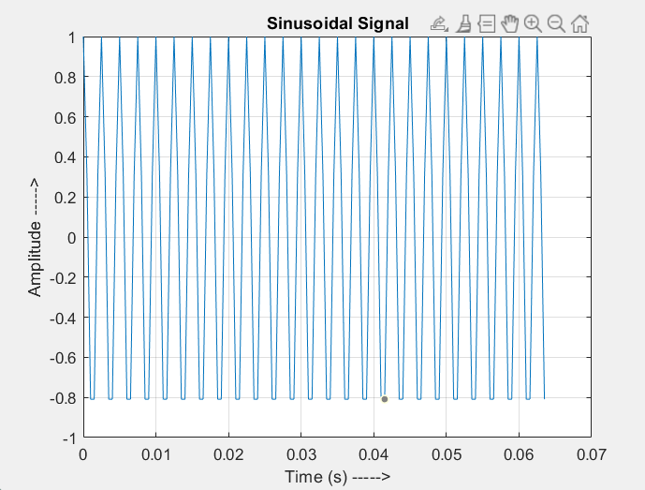
soundsc(x, fs);

6. Generate the following signals with R amplitudes & R*10 Samples.
i. Ramp Function
ii. Saw-tooth.
iii. Triangular Signal.
iv. Rectangular Signal.
v. Sinc Function.
vi. Square Wave.
vii. Chirp Wave.
viii. Cubic Function.
ix. Tan(x).
x. X3+Y3

CODE
% Define parameters
R = 10; % Amplitude
N = R * 10; % Number of samples
t = linspace(0, 2*pi, N); % Time vector (or sample index)
x = linspace(-R, R, N); % For cubic and other signals

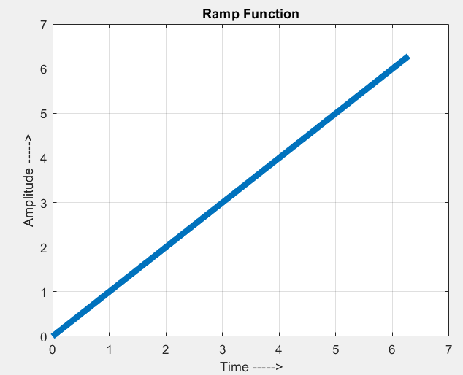
% i. Ramp Function
ramp = t; % Linear ramp
figure;
plot(t, ramp);
title('Ramp Function');
xlabel('Time ----->');
ylabel('Amplitude ----->');
grid on;

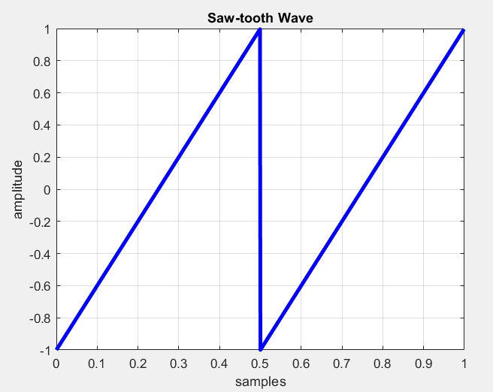
% ii. Saw-tooth
sawtooth_wave = R * sawtooth(t);
figure;
plot(t, sawtooth_wave);
title('Saw-tooth Wave');
xlabel('Time ----->');
ylabel('Amplitude ----->');
grid on;

% iii. Triangular Signal
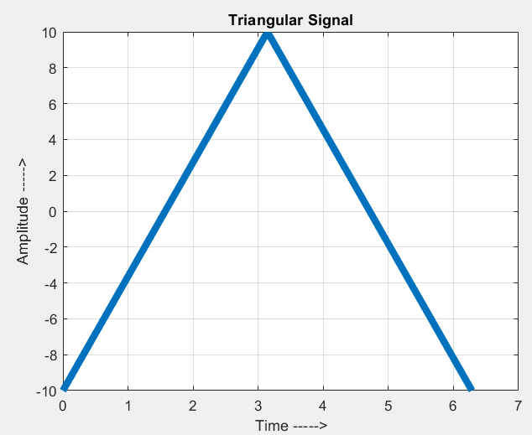
triangular_wave = R * sawtooth(t, 0.5); % Sawtooth with symmetry = 0.5
figure;
plot(t, triangular_wave);
title('Triangular Signal');
xlabel('Time ----->');
ylabel('Amplitude ----->');
grid on;

% iv. Rectangular Signal
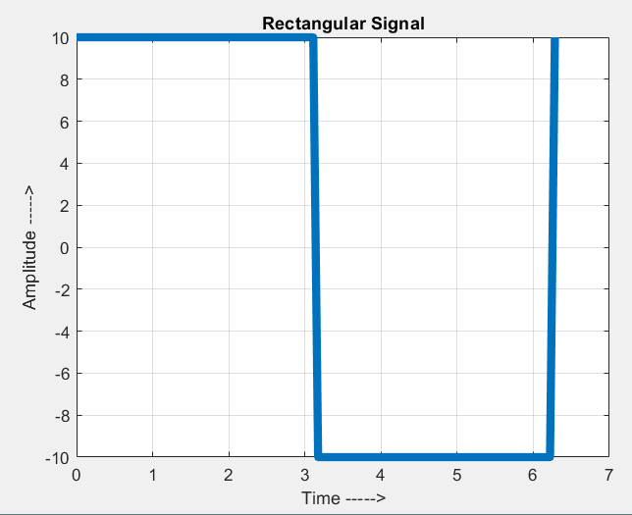
rectangular_wave = R * square(t); % Square wave with 50% duty cycle
figure;
plot(t, rectangular_wave);
title('Rectangular Signal');
xlabel('Time ----->');
ylabel('Amplitude ----->');
grid on;

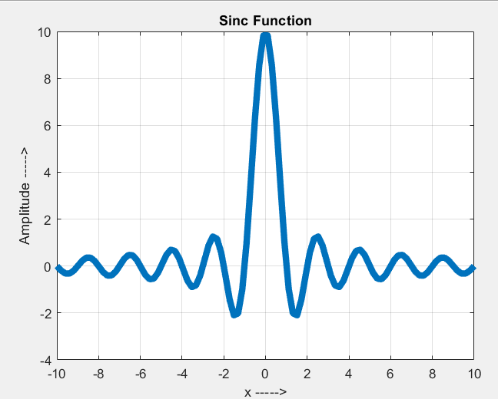
% v. Sinc Function
sinc_wave = R * sinc(x);
figure;
plot(x, sinc_wave);
title('Sinc Function');
xlabel('x ----->');
ylabel('Amplitude ----->');
grid on;

% vi. Square Wave
square_wave = R * square(t); % Same as rectangular
figure;
plot(t, square_wave);
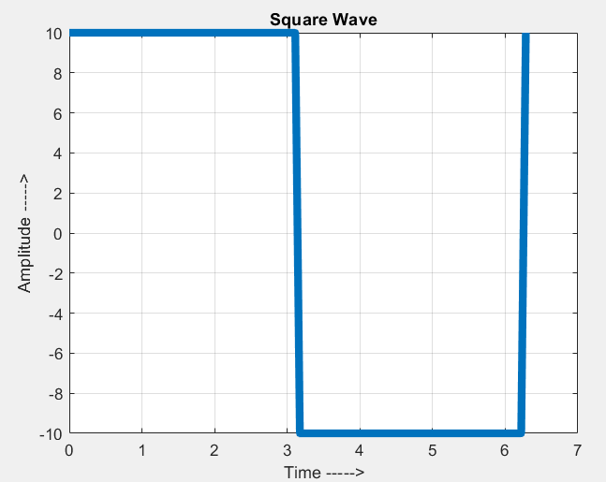
title('Square Wave');
xlabel('Time ----->');
ylabel('Amplitude ----->');
grid on;

% vii. Chirp Wave
chirp_wave = R * chirp(t, 0, max(t), R);
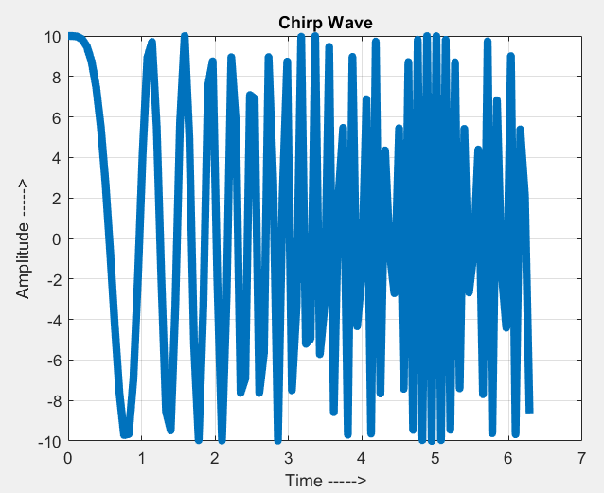
% Start frequency 0 Hz, end frequency R Hz
figure;
plot(t, chirp_wave);
title('Chirp Wave');
xlabel('Time ----->');
ylabel('Amplitude ----->');
grid on;

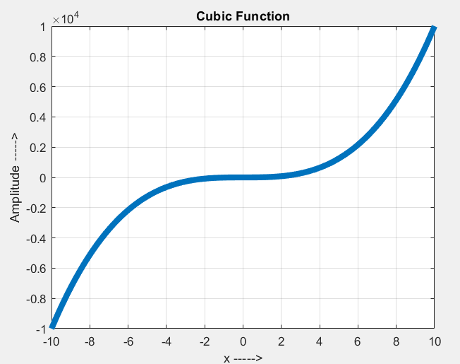
% viii. Cubic Function
cubic_wave = R * x.^3;
figure;
plot(x, cubic_wave);
title('Cubic Function');
xlabel('x ----->');
ylabel('Amplitude ----->');
grid on;

% ix. Tan(x)
tan_wave = R * tan(x);
figure;
plot(x, tan_wave);
title('Tan(x)');
xlabel('x ----->');
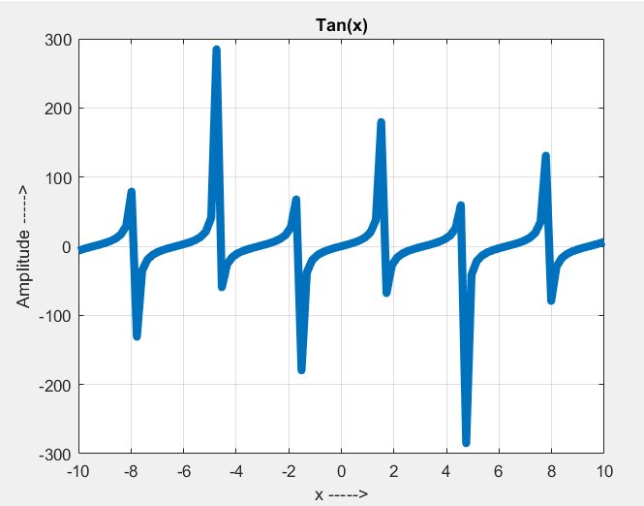
ylabel('Amplitude ----->');
grid on;

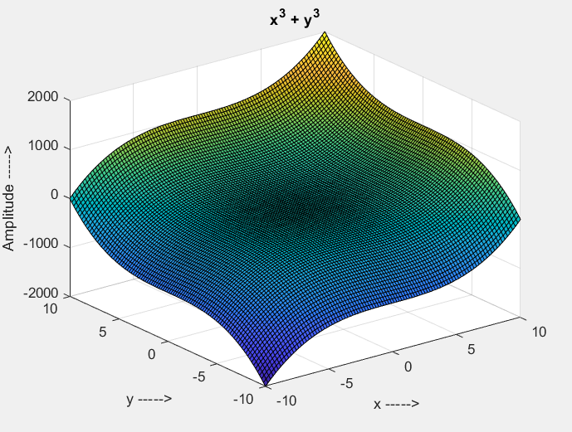
% x. x^3 + y^3
y = linspace(-R, R, N);
[X, Y] = meshgrid(x, y);
cubic_sum = X.^3 + Y.^3;
figure;
surf(X, Y, cubic_sum);
title('x^3 + y^3');
xlabel('x ----->');
ylabel('y ----->');
zlabel('Amplitude ----->');
grid on;

7. Use the any sequences in (6) for the following signal operations.
i. Sum.
CODE:
clear all;
clc;

% Parameters
fs = 1000; % Sampling frequency (1 kHz)
f = 2; % Frequency of the waves (2 Hz)
t = 0:1/fs:1-1/fs; % Time vector from 0 to 1 second

% Generate Sawtooth Wave
x1 = sawtooth(2 * pi * f * t);
figure;
plot(t, x1, 'b', 'LineWidth', 2);
xlabel('Time (s)');
ylabel('Amplitude');
title('Sawtooth Wave');
grid on;

% Generate Square Wave
x2 = square(2 * pi * f * t);
figure;
plot(t, x2, 'r', 'LineWidth', 2);
xlabel('Time (s)');
ylabel('Amplitude');
title('Square Wave');
grid on;
% Add the Two Signals
y = x1 + x2;
% Plot Both Signals and Their Sum
figure;
subplot(3, 1, 1);
plot(t, x1, 'b', 'LineWidth', 2);
xlabel('Time (s)');
ylabel('Amplitude');
title('Sawtooth Wave');
grid on;
subplot(3, 1, 2);
plot(t, x2, 'r', 'LineWidth', 2);
xlabel('Time (s)');
ylabel('Amplitude');
title('Square Wave');
grid on;
subplot(3, 1, 3);
plot(t, y, 'k', 'LineWidth', 2);
xlabel('Time (s)');
ylabel('Amplitude');
title('Addition of Sawtooth and Square Waves');
grid on;

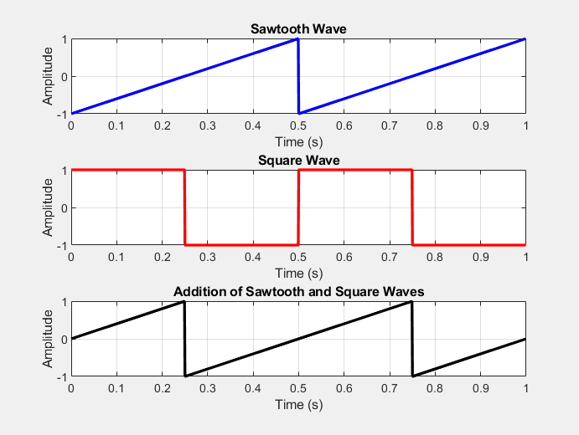

ii. Multiply.
clear all;
clc;
% Parameters
fs = 1000; % Sampling frequency (1 kHz)
f = 2; % Frequency of the waves (2 Hz)
t = 0:1/fs:1-1/fs; % Time vector from 0 to 1 second
% Generate Sawtooth and Square Waves
x1 = sawtooth(2 * pi * f * t); % Sawtooth wave
x2 = square(2 * pi * f * t); % Square wave
% Multiply the Two Signals
y = x1 .* x2;
% Plot Both Signals and Their Product
figure;
subplot(3, 1, 1);
plot(t, x1, 'b', 'LineWidth', 2);
xlabel('Time (s)');
ylabel('Amplitude');
title('Sawtooth Wave');
grid on;

subplot(3, 1, 2);
plot(t, x2, 'r', 'LineWidth', 2);
xlabel('Time (s)');
ylabel('Amplitude');
title('Square Wave');
grid on;

subplot(3, 1, 3);
plot(t, y, 'k', 'LineWidth', 2);
xlabel('Time (s)');
ylabel('Amplitude');
title('Product of Sawtooth and Square Waves');
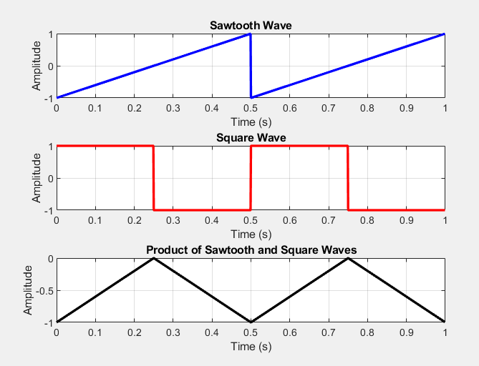
grid on;

iii. Fold.
clear all;
clc;

% Parameters
fs = 1000; % Sampling frequency (1 kHz)
f = 2; % Frequency of the waves (2 Hz)
t = 0:1/fs:1-1/fs; % Time vector from 0 to 1 second

% Generate Sawtooth and Square Waves
x1 = sawtooth(2 * pi * f * t); % Sawtooth wave
x2 = square(2 * pi * f * t); % Square wave

% Fold (Time Reversal)
x1_folded = fliplr(x1); % Folded sawtooth wave
x2_folded = fliplr(x2); % Folded square wave

% Plot Original and Folded Signals
figure;

subplot(2, 2, 1);
plot(t, x1, 'b', 'LineWidth', 2);
xlabel('Time (s)');
ylabel('Amplitude');
title('Original Sawtooth Wave');
grid on;

subplot(2, 2, 2);
plot(t, x1_folded, 'r', 'LineWidth', 2);
xlabel('Time (s)');
ylabel('Amplitude');
title('Folded Sawtooth Wave');
grid on;

subplot(2, 2, 3);
plot(t, x2, 'b', 'LineWidth', 2);
xlabel('Time (s)');
ylabel('Amplitude');
title('Original Square Wave');
grid on;

subplot(2, 2, 4);
plot(t, x2_folded, 'r', 'LineWidth', 2);
xlabel('Time (s)');
ylabel('Amplitude');
title('Folded Square Wave');
grid on;

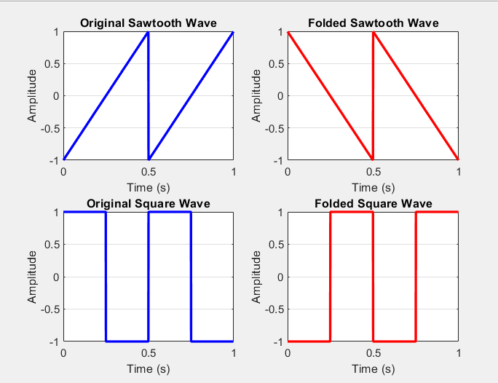
iv. Shift (By R Samples).
clear all;
clc;

% Parameters
fs = 1000; % Sampling frequency (1 kHz)
f = 2; % Frequency of the wave (2 Hz)
t = 0:1/fs:1-1/fs; % Time vector from 0 to 1 second
R = 100; % Shift by 100 samples

% Generate Square Wave
x = square(2 * pi * f * t); % Square wave

% Shift Square Wave
x_shifted = circshift(x, R); % Circular shift by R samples

% Plot Original and Shifted Square Wave
figure;

subplot(2, 1, 1);
plot(t, x, 'b', 'LineWidth', 2);
xlabel('Time (s)');
ylabel('Amplitude');
title('Original Square Wave');
grid on;

subplot(2, 1, 2);
plot(t, x_shifted, 'r', 'LineWidth', 2);
xlabel('Time (s)');
ylabel('Amplitude');
title(['Shifted Square Wave (by ', num2str(R), ' Samples)']);
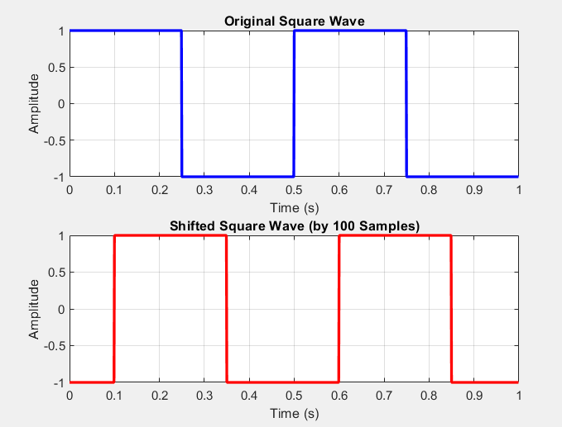
grid on;

Questions
Q1 Differentiate between Discrete & Continuous Signal
Continuous Signal:
A continuous signal or a continuous-time signal is a varying quantity (a signal) whose domain, which is often time, is a continuum (e.g., a connected interval of the reals). ... A signal of continuous amplitude and time is known as a continuous-time signal or an analog signal.
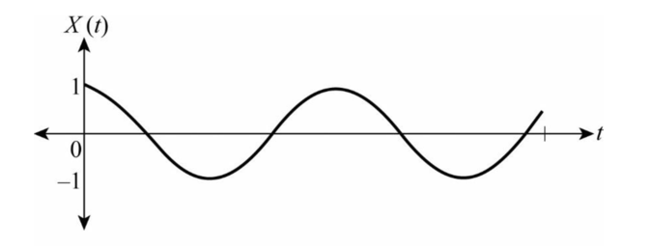
Discrete Signal:
A discrete-time signal is a sequence of values that correspond to particular instants in time. The time instants at which the signal is defined are the signal's sample times, and the associated signal values are the signal's samples.
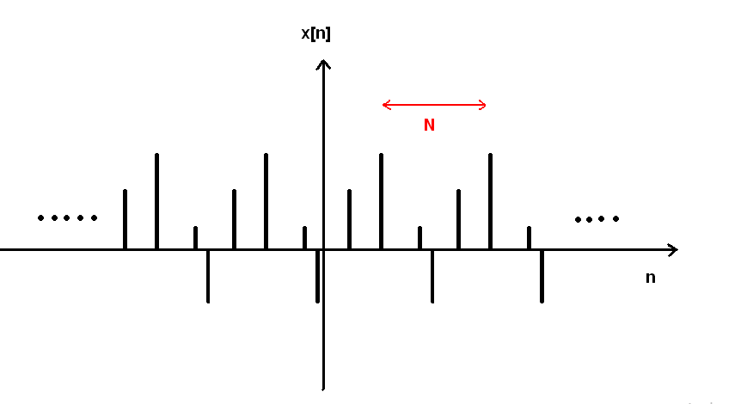

Q2 What is the difference between plot and stem commands in MATLAB?
Both plot and stem functions are used to represent a curve in MATLAB. The main point of difference between the two is that plot displays the continuous values for the curve. ... On the other hand, stem displays the discrete values of the points on the curve.

Q3 What is the effect of using time vector with smaller step-size?
If you decrease the step size or increase the number of iterations, the results are more accurate, but the simulation runs slower. If you increase the step size or decrease the number of iterations, the simulation runs faster, but the results are less accurate.

Q4 Write the commands used for the followings tasks.

i. Labeling the Axes: xlabel('X-axis Label'); ylabel('Y-axis Label');
ii. Title of Graph: title('Graph Title');
iii. Grid lines for Graph: grid on;
iv. Auto-scaling the axes: axis auto;
v. Multiple Graphs on same axis: hold on; plot(x1, y1); plot(x2, y2); hold off;
vi. Multiple Graphs in one Figure Window: subplot(m, n, p); plot(x, y);

Q5 Is there any difference between Discrete & Digital Signal

In discrete signal we can have any domain for each time(N),but in the digital signal we cant have any domain ,and you have standard value for each domain. A discrete time signal is quantised in time only, a digital signal is quantised both in time and amplitude.

